**Pick three concepts covered in Lecture 9 - Interaction (e.g., Brushing & Linking) and relate them to the taxonomy presented in Heer & Shneiderman Table. How do the interaction concepts fit to their taxonomy?**

Taxonomy:

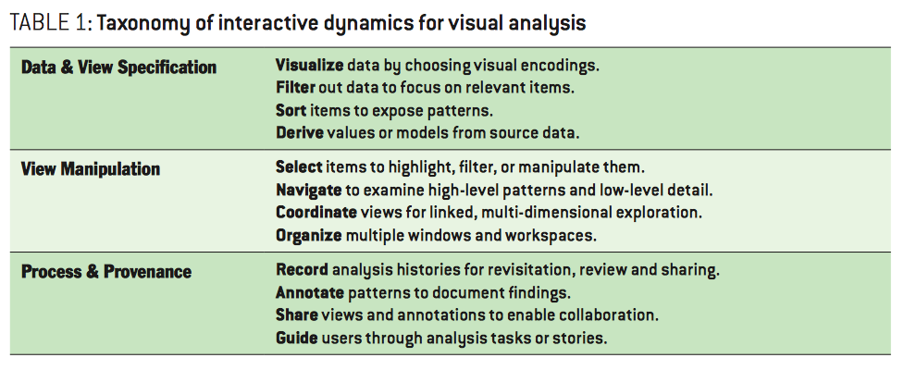

Concepts in lecture 9 - Interaction:

Overview & Detail   
Focus + Context  
Brushing & Linking   
Filtering   
Animation  
Zooming  
Off-the-desktop Interaction

1. Overview + Detail

Presenting the data with two images: One shows a rough overview of the complete information space and neglects details. The other shows a small portion of the information space and visualizes details. Images can be shown either sequentially or in parallel.

Navigation is very important here. It is about how analysts navigate a visualization (the ‘mantra’ Overview first, zoom and filter, then details-on-demand). First you have to decide where the visualization starts (detail of overview) and then what to show in detail or overview. You also consider if you give more information while going into detail. This is the semantic zoom. If you only go to different scales but the representation stays the same, it is a geometric zoom.

1. Focus + Context

Enable viewers to see the object of primary interested presented in full detail (focus) while at the same time getting an overview- impression of all the surrounding information available (context). Typically all in the same image (as opposed to two views for overview + detail), but that’s not an absolute requirement.

Here is organize important. As stated before, the focus en context is typically in the same image so there is a multiple window and workspace that should be organized.

1. Brushing & Linking

Combine different visualization methods to overcome the shortcomings of individual techniques. Interactive changes made in one visualization are automatically reflected in the other visualization(s).

Coordinate views for linked, multi-dimension exploration is a link with brushing & linking because it is both about how to combine different visualizations to get different perspectives. This can be done with multiple displays of the same type of visualisation with different data or different visualisation of the same data. But with brushing and linking, the process of selecting items in one display to highlight (or hide) corresponding data in the other views in mend.

1. Filtering

Filtering: Limit the amount of displayed information by a set of predefined criteria. Dynamic querying: Continually update the data that is filtered and visualized based on interactions.

Here selection is important. Selections often determine a set of objects to be manipulated, enabling highlighting, annotation, filtering, or details-on-demand. It is closely related to filtering (taxonomy as well as the concept from the lecture) because selections can be used to identify items to remove or highlight in the display.